Код окна LoginWindow.xaml:

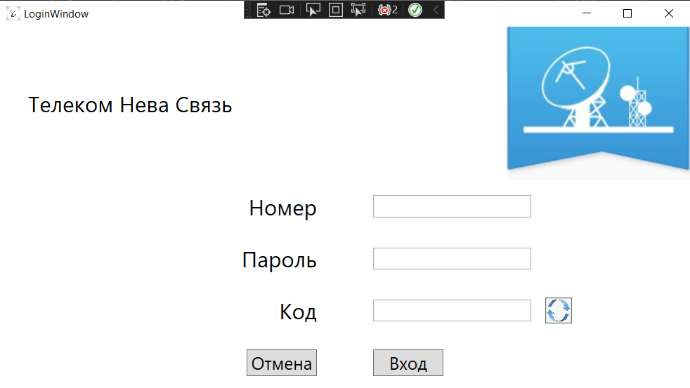

<Grid>

<Grid.RowDefinitions>

<RowDefinition Height="175"/>

<RowDefinition/>

<RowDefinition/>

<RowDefinition/>

<RowDefinition/>

</Grid.RowDefinitions>

<Grid.ColumnDefinitions>

<ColumnDefinition/>

<ColumnDefinition/>

</Grid.ColumnDefinitions>

<TextBlock Text="Код" VerticalAlignment="Center" HorizontalAlignment="Right" FontSize="25" Grid.Row="3" Margin="32 0"/>

<StackPanel Orientation="Horizontal" Grid.Row="3" Grid.Column="1">

<TextBox x:Name="CodeTb" VerticalAlignment="Center" HorizontalAlignment="Left" Width="180" Margin="32 0 16 0" Height="25"/>

<Button x:Name="UpdBtn" VerticalAlignment="Center" Click="UpdBtn_Click" Background="Transparent" Width="30" Height="30">

<Image VerticalAlignment="Center" HorizontalAlignment="Center" Source="\Resources\На авторизацию_Обновление кода.jpg" Width="30" Height="30"/>

</Button>

</StackPanel>

<Image Source="\Resources\Лого ТНС.jpg" Grid.Column="1" VerticalAlignment="Center" HorizontalAlignment="Right"/>

<TextBlock Text="Телеком Нева Связь" VerticalAlignment="Center" HorizontalAlignment="Left" Margin="32 0" FontSize="25"/>

<TextBlock Text="Номер" VerticalAlignment="Center" HorizontalAlignment="Right" FontSize="25" Grid.Row="1" Margin="32 0"/>

<TextBlock Text="Пароль" VerticalAlignment="Center" HorizontalAlignment="Right" FontSize="25" Grid.Row="2" Margin="32 0"/>

<Button x:Name="CancelBtn" VerticalAlignment="Center" HorizontalAlignment="Right" Grid.Row="4" Margin="32 0" Content="Отмена" Width="80" FontSize="20" Click="CancelBtn_Click"/>

<Button x:Name="AuthBtn" VerticalAlignment="Center" HorizontalAlignment="Left" Grid.Row="4" Margin="32 0" Click="AuthBtn_Click" Content="Вход" FontSize="20" Width="80" Grid.Column="1"/>

<TextBox x:Name="LoginTb" VerticalAlignment="Center" HorizontalAlignment="left" Margin="32 0" Grid.Row="1" Grid.Column="1" Width="180" Text="{Binding Login}" Height="25" />

<TextBox x:Name="PassTb" VerticalAlignment="Center" HorizontalAlignment="Left" Margin="32 0" Grid.Row="2" Grid.Column="1" Text="{Binding Password}" Width="180" Height="25"/>

</Grid>

Код окна LoginWindow.xaml.cs:

public partial class LoginWindow : Window

{

public LoginWindow()

{

InitializeComponent();

DataContext = this;

}

private void CancelBtn_Click(object sender, RoutedEventArgs e)

{

MessageBoxResult messageBoxResult = MessageBox.Show("Вы действительно хотите закрыть?", "Закрыть", MessageBoxButton.OKCancel, MessageBoxImage.Question);

if (messageBoxResult == MessageBoxResult.OK)

{

this.Close();

}

}

private void AuthBtn_Click(object sender, RoutedEventArgs e)

{

try

{

User user = TelecomNevaEntities.GetContext().Users.FirstOrDefault(p => p.PhoneNumb == LoginTb.Text && p.Password == PassTb.Text);

if (user != null)

{

if (CodeTb.Text == "")

{

CodeWindow code = new CodeWindow();

code.Show();

}

if (CodeTb.Text == CodeClass.Code)

{

AuthStorage.Role = user.RoleID;

AuthStorage.Name = user.PhoneNumb;

MainWindow mainWindow = new MainWindow();

mainWindow.Show();

this.Close();

}

}

else

{

MessageBox.Show("Неверные данные, пожалуйста, попробуйте еще раз");

}

}

catch (Exception ex)

{

MessageBox.Show(ex.Message.ToString());

}

}

//Метод для вывода диалогового окна с капчей

private void UpdBtn_Click(object sender, RoutedEventArgs e)

{

CodeWindow code = new CodeWindow();

code.Show();

}

}

Код окна CodeWindow.xaml:

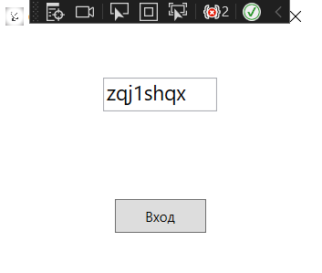

<Grid>

<Grid.RowDefinitions>

<RowDefinition/>

<RowDefinition/>

</Grid.RowDefinitions>

<TextBox x:Name="CodeTb" Grid.Row="0" Width="100" Height="30" FontSize="18" HorizontalAlignment="Center" VerticalAlignment="Center" />

<Button x:Name="EnterBtn" Grid.Row="1" Width="80" Height="30" Content="Вход" VerticalAlignment="Center" HorizontalAlignment="Center" Click="EnterBtn_Click"/>

</Grid>

Код окна CodeWindow.xaml.cs:

public partial class CodeWindow : Window

{

string _code { get; set; }

public bool _isCorrect {get;set;}

public CodeWindow()

{

InitializeComponent();

_code = CodeClass.CreateCode();

CodeTb.Text = _code;

CodeClass.Code = _code;

}

private void EnterBtn_Click(object sender, RoutedEventArgs e)

{

this.Close();

}

}

Код страницы AbonentPage.xaml:

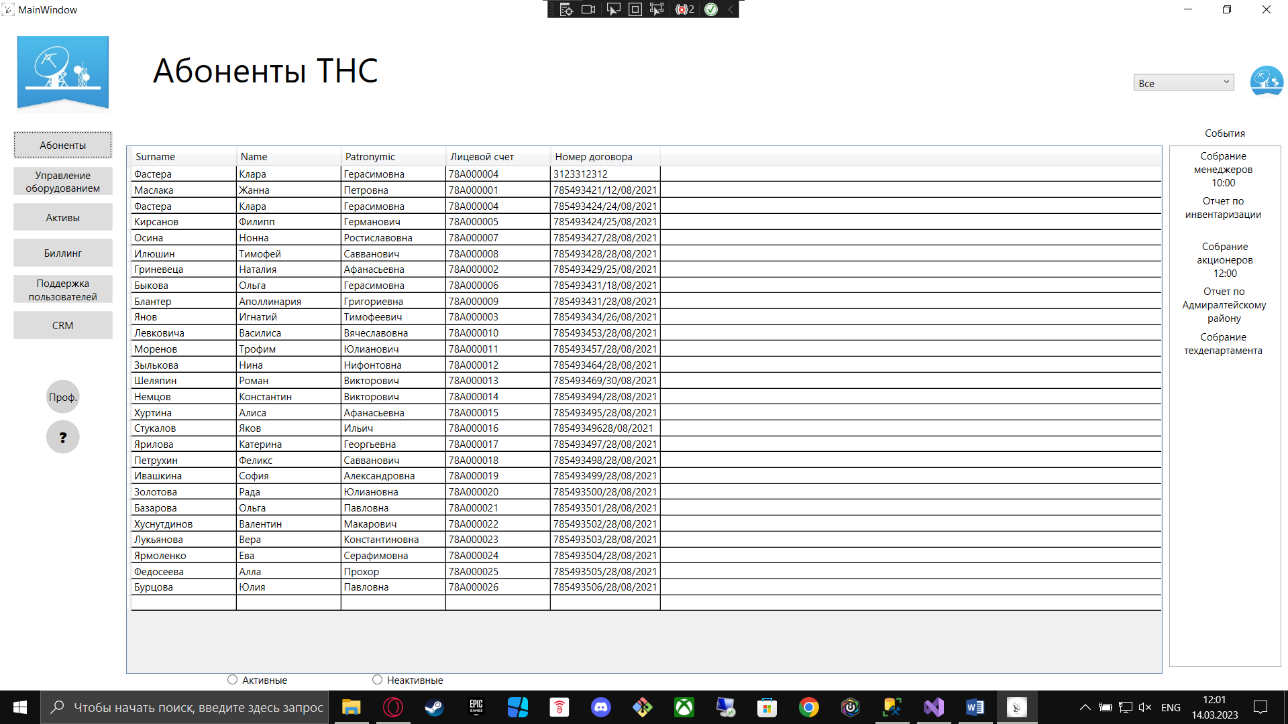

<Grid>

<Grid.RowDefinitions>

<RowDefinition Height="150"/>

<RowDefinition/>

<RowDefinition Height="20"/>

</Grid.RowDefinitions>

<Grid.ColumnDefinitions>

<ColumnDefinition/>

<ColumnDefinition Width="150"/>

</Grid.ColumnDefinitions>

<TextBlock Text="Абоненты ТНС" VerticalAlignment="Center" HorizontalAlignment="Left" FontSize="40" Margin="32 -32 0 0"/>

<ComboBox x:Name="UserCb" Width="120" Height="20" SelectionChanged="UserCb_SelectionChanged" VerticalAlignment="Center" HorizontalAlignment="Right" Margin="64 0" Grid.ColumnSpan="2"/>

<Ellipse Width="40" Height="40" Grid.Column="1" Margin="100 0 0 0">

<Ellipse.Fill>

<ImageBrush ImageSource="\Resources\Лого ТНС.jpg" Stretch="UniformToFill"/>

</Ellipse.Fill>

</Ellipse>

<DataGrid x:Name="AbonentData" Grid.Row="1" MinColumnWidth="125" ItemsSource="{Binding EjectApp}" AutoGenerateColumns="False">

<DataGrid.Columns>

<DataGridTextColumn Header="Surname" Binding="{Binding Abonent.LastName}"/>

<DataGridTextColumn Header="Name" Binding="{Binding Abonent.FirstName}"/>

<DataGridTextColumn Header="Patronymic" Binding="{Binding Abonent.Patronymic}"/>

<DataGridTextColumn Header="Лицевой счет" Binding="{Binding Abonent.AbonentID}"/>

<DataGridTextColumn Header="Номер договора" Binding="{Binding ApplicNumb}"/>

</DataGrid.Columns>

</DataGrid>

<Border Grid.Column="1" Grid.Row="0" Width="134" Background="White" Height="30" VerticalAlignment="Bottom">

<TextBlock Text="События" VerticalAlignment="Center" HorizontalAlignment="Center" />

</Border>

<ListBox Grid.Row="1" Grid.Column="1" Margin="8 0 8 8">

<ListBoxItem>

<TextBlock Text="Собрание менеджеров 10:00" TextAlignment="Center" Height="50" TextWrapping="Wrap" Margin="8 0" Width="100" VerticalAlignment="Center" HorizontalAlignment="Center"/>

</ListBoxItem>

<ListBoxItem>

<TextBlock Text="Отчет по инвентаризации" TextAlignment="Center" TextWrapping="Wrap" Height="50" Margin="8 0" Width="100" VerticalAlignment="Center" HorizontalAlignment="Center"/>

</ListBoxItem>

<ListBoxItem>

<TextBlock Text="Собрание акционеров 12:00" TextAlignment="Center" TextWrapping="Wrap" Height="50" Margin="20 0" Width="80" VerticalAlignment="Center" HorizontalAlignment="Center"/>

</ListBoxItem>

<ListBoxItem>

<TextBlock Text="Отчет по Адмиралтейскому району" TextAlignment="Center" TextWrapping="Wrap" Height="50" Margin="8 0" Width="102" VerticalAlignment="Center" HorizontalAlignment="Center"/>

</ListBoxItem>

<ListBoxItem>

<TextBlock Text="Собрание техдепартамента" TextAlignment="Center" TextWrapping="Wrap" Height="50" Margin="8 0" Width="100" VerticalAlignment="Center" HorizontalAlignment="Center"/>

</ListBoxItem>

</ListBox>

<StackPanel Orientation="Horizontal" Grid.Row="2" Margin="120 0">

<RadioButton x:Name="ActiveRb" Content="Активные" Checked="ActiveRb_Checked"/>

<RadioButton x:Name="NotActiveRb" Content="Неактивные" Margin="100 0" Checked="NotActiveRb_Checked"/>

</StackPanel>

</Grid>

Код страницы AbonentPage.xaml.cs:

public partial class AbonentPage : Page

{

public List<EjectApp> Abonent { get; set; }

public AbonentPage()

{

InitializeComponent();

AbonentData.ItemsSource = null;

Abonent = TelecomNevaEntities.GetContext().EjectApps.ToList();

DataContext = this;

AbonentData.ItemsSource = Abonent;

List<Employee> employees = TelecomNevaEntities.GetContext().Employees.ToList();

employees.Insert(0, new Employee

{

Surname = "Все"

});

UserCb.ItemsSource = employees;

UserCb.DisplayMemberPath = "Surname";

UserCb.SelectedIndex = 0;

}

private void ActiveRb_Checked(object sender, RoutedEventArgs e)

{

List<EjectApp> abonents = TelecomNevaEntities.GetContext().EjectApps.Where(p => p.StatusID == 1 || p.StatusID == 2).ToList();

AbonentData.ItemsSource = abonents;

}

private void NotActiveRb_Checked(object sender, RoutedEventArgs e)

{

List<EjectApp> ejects = TelecomNevaEntities.GetContext().EjectApps.Where(p => p.StatusID == 3).ToList();

AbonentData.ItemsSource = ejects;

}

private void Update()

{

List<EjectApp> ejects = TelecomNevaEntities.GetContext().EjectApps.ToList();

if (UserCb.SelectedIndex > 0)

{

ejects = ejects.Where(p=> p.EmployeeID == (UserCb.SelectedItem as Employee).EmployeeID).ToList();

}

AbonentData.ItemsSource = ejects;

}

private void UserCb_SelectionChanged(object sender, SelectionChangedEventArgs e)

{

Update();

}

}

Код страницы CrmPage.xaml:

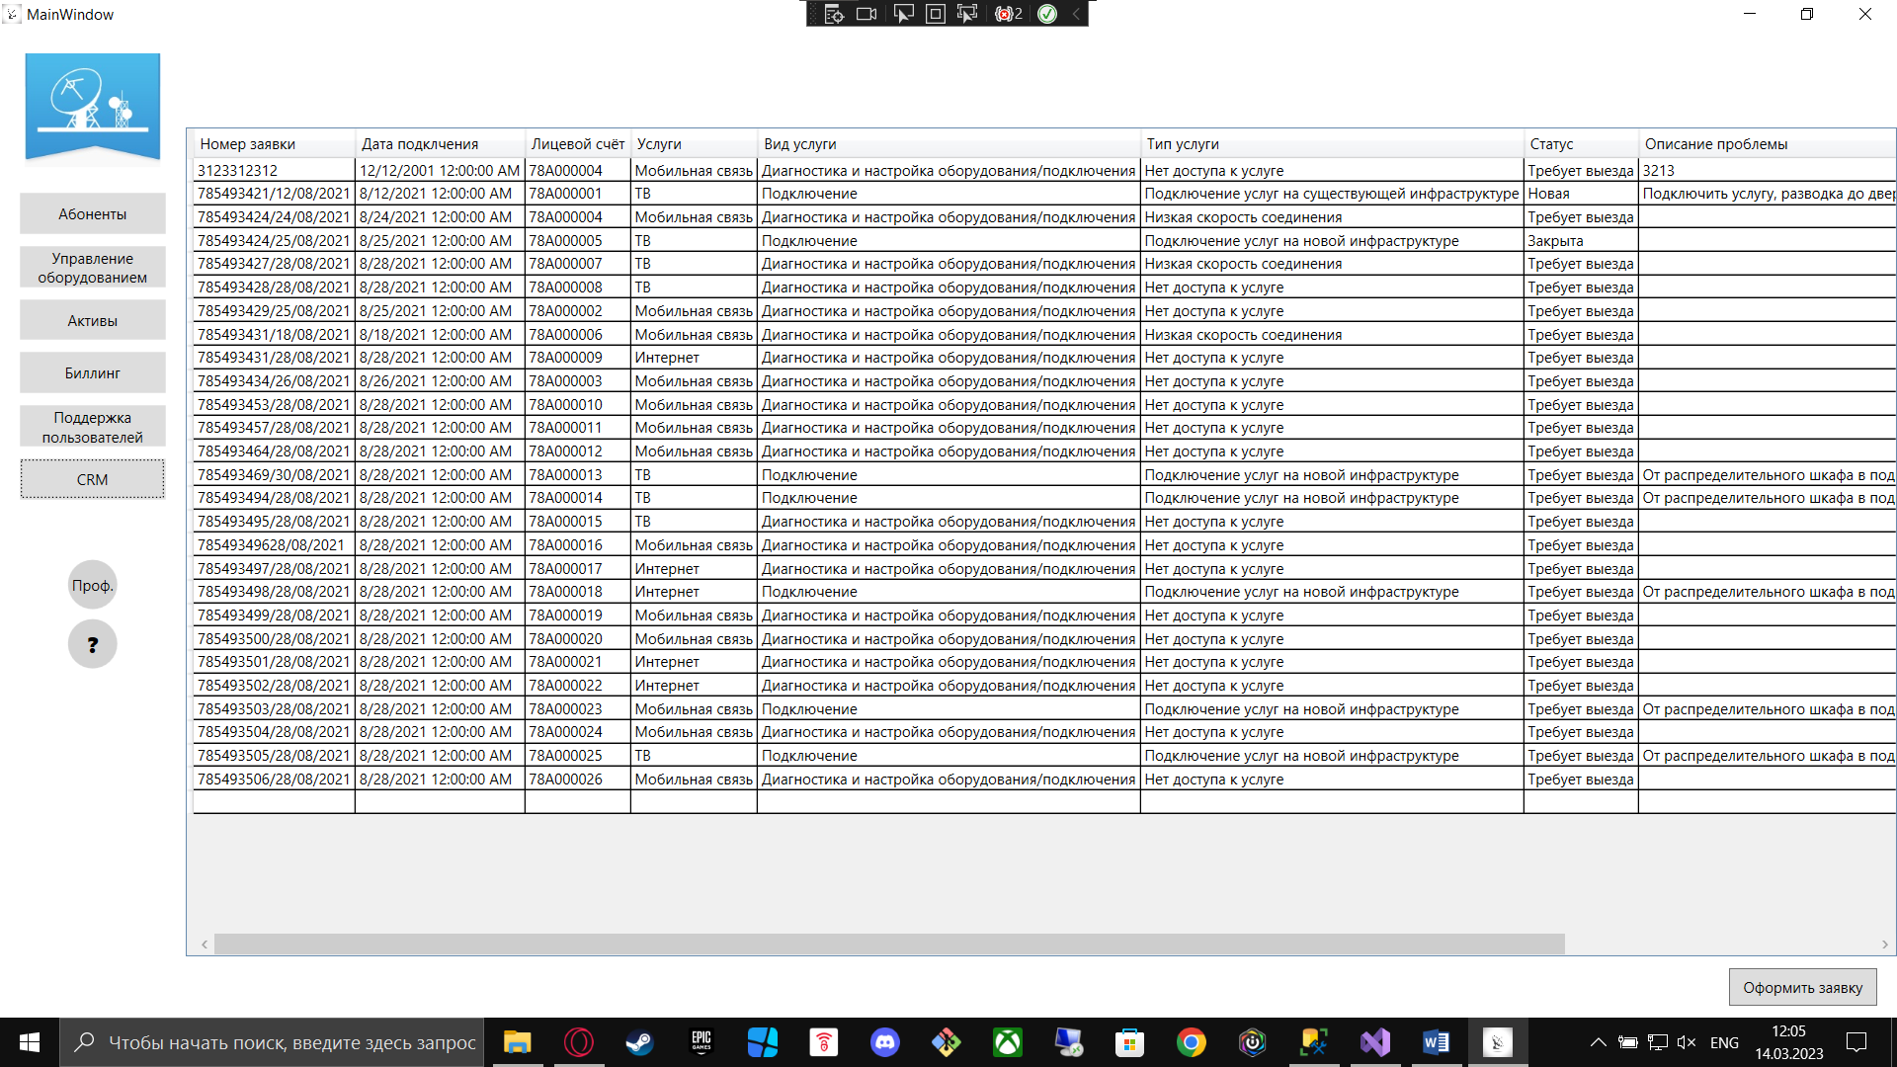

<Grid>

<Grid.RowDefinitions>

<RowDefinition Height="80"/>

<RowDefinition/>

<RowDefinition Height="50"/>

</Grid.RowDefinitions>

<DataGrid x:Name="CRMData" AutoGenerateColumns="False" ItemsSource="{Binding Application}" HorizontalAlignment="Center" Grid.Row="1">

<DataGrid.Columns>

<DataGridTextColumn Header="Номер заявки" Binding="{Binding ApplicNumb}"/>

<DataGridTextColumn Header="Дата подклчения" Binding="{Binding DateOfStart}"/>

<DataGridTextColumn Header="Лицевой счёт" Binding="{Binding AbonentID}"/>

<DataGridTextColumn Header="Услуги" Binding="{Binding Service.Name}"/>

<DataGridTextColumn Header="Вид услуги" Binding="{Binding ServiceView.Name}"/>

<DataGridTextColumn Header="Тип услуги" Binding="{Binding ServiceType.Name}"/>

<DataGridTextColumn Header="Статус" Binding="{Binding Status.Name}"/>

<DataGridTextColumn Header="Описание проблемы" Binding="{Binding Opisanie}"/>

<DataGridTextColumn Header="Тип проблемы" Binding="{Binding Problem.Name}"/>

<DataGridTextColumn Header="Дата закрытия" Binding="{Binding DateOfRealiz}"/>

</DataGrid.Columns>

</DataGrid>

<Button x:Name="AddBtn" Content="Оформить заявку" Grid.Row="2" VerticalAlignment="Center"

HorizontalAlignment="Right" Margin="16 0" Width="120" Height="30" Click="AddBtn_Click" />

</Grid>

Код страницы CrmPage.xaml.cs:

public partial class CrmPage : Page

{

public List<EjectApp> Applications { get; set; }

public CrmPage()

{

InitializeComponent();

CRMData.ItemsSource = null;

Applications = TelecomNevaEntities.GetContext().EjectApps.ToList();

DataContext = this;

CRMData.ItemsSource = Applications;

}

private void AddBtn_Click(object sender, RoutedEventArgs e)

{

NavigationService.Navigate(new Pages.AddPage());

}

}